 | Contract management System  Technical Design Document  1.0
 | Prepared By / Last Updated By | Reviewed By | Approved By
Name | Anish Sharma | Abhishek | Akshay Katoch
Role | Scrum Master | Team Member | Team Member
Signature
Date

Table of Contents

1.0 Introduction 3
1.1 Purpose of this document 3
1.2 Scope 3
1.3 Intended Audience 3
1.4 Definition & Acronyms 3
2.0 Conventions and Standards Followed 4
3.0 Assumptions, Dependencies and Risks 4
3.1 Assumptions: 4
3.2 Dependencies: 4
4.0 Schematic Diagram 4
5.0 Use Case Realization 5
5.1.1 Supplier/Admin Registration 5
a. Functional Requirement 6
b. UI Validations 6
c. UI Controls 7
d. UI Methods Definition 8
e. UI Design 9
6.0 Database Design 10
6.1 Data Model 10
6.2 Tables Structure 10
7.0 Change Log 13

Introduction

Purpose of this document
The purpose of the detail design document is to define the detailed design for all the components of Contract Management that are specified in the Business Requirement/Use case document. All the low level components, interfaces and integrations are detailed out in this document.

Scope
This sub-section shall state the scope of this detailed design document
• Create and maintain supplier information.
• Create and maintain admin information.
• Create and maintain contracts information

Intended Audience
The intended audience for this document are
- Developers, testers, other associates in the project
- Technical lead, Scrum Master
- Product Owner

Definition & Acronyms
Acronyms | Definitions
CMS | Contract management System

Conventions and Standards Followed
The modules under scope needs to adhere to the coding standards and guidelines


Assumptions, Dependencies and Risks

Assumptions:
- Once the application is built the Contract management system will manually load the user list into the system.
- There will be no concurrent users for the application. The Contract information will be maintained by the supplier.
- Any changes to the design mentioned in the BRD would be taken as a Change Request

Dependencies:
- Availability of database design characteristics & access shall be defined by the Resource availability throughout each of the sprint

Schematic Diagram
A schematic, or schematic diagram, is a representation of the elements of a system using abstract, graphic symbols rather than realistic pictures. It gives an overview of overall system

Use Case Realization

Supplier/Admin login

Functional Requirement
. Login Page checks the authentication of the user and based on his role, directs the user to the respective page. User will provided with respective home page and the same user will allowed to see contract’s status.

UI Validations
- User Id and Password fields are mandatory.
- Invalid User Id and / or password should not allow the user to get into the system

UI Controls
# | UI Component | Type | Name | Details
1 | Username | Label | label_For_User_Id
2 | Username | Text field | Textfield_user | To enter username
3 | password | Label | Label_for_password
4 | password | Text field | Textfield_password | To enter password

UI Methods Definition
Method Name | Parameter | Details
Registor_as_admin_button | Object User | Allows the admin to register his/her details
Registor_as_supplier_button | Object User | Allows the supplier to register his/her details
SignIn_button | Object User | Allows the user to login to the system.

UI Design
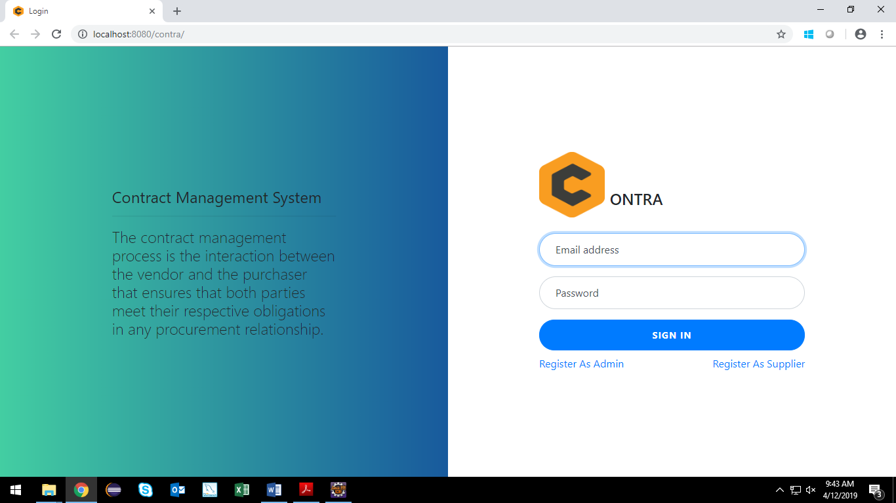

Supplier Registration

Functional Requirement
. Supplier register page checks the authentication of the user and based on his role, directs the user to the supplier home page.

UI Validations
- All fields are mandatory.
- Password should have maximum 15 alphanumeric, space & can contain special characters (ex.!,@,#,%,*,& etc.)
- The Email ID format must be checked.
- Contact Number must be of 10 digits’ length.
- Age should be 2 digit numeric value.
- First Name, Last Name should contain only alphabets.
- Gender should be chosen from the dropdown options.
- Zip code should be 5 digits.

UI Controls
# | UI Component | Type | Name | Details
1 | First Name | Text Field | first_name | To enter first name
2 | Last Name | Text Field | last_name | To enter last name
3 | DOB | Text Field | dob | To enter date
4 | Age | Text Field | age | To enter age
5 | Gender | Text Field | gender | To enter gender
6 | Contact Number | Text Field | number | To enter contact no
7 | Alternate Contact No. | Text Field | alt_number | To enter alternate contact number
8 | Email Id | Text Field | emailId | To enter email id
9 | Password | Password Field | password | To enter password
10 | Address Line 1 | Text Field | Address_l1 | To enter the address
11 | Address Line 2 | Text Field | Address_l2 | To enter the address
12 | City | Text Field | City | To enter city name
13 | State | Text Field | state | To enter the state
14 | Zipcode | Text Field | zip | To enter the zip code

UI Methods Definition
Method Name | Parameter | Details
Sign_Button | object user, | Allows the user return to the login page
Register_button | Object user | Allows the user to submit the entered details.

UI Design
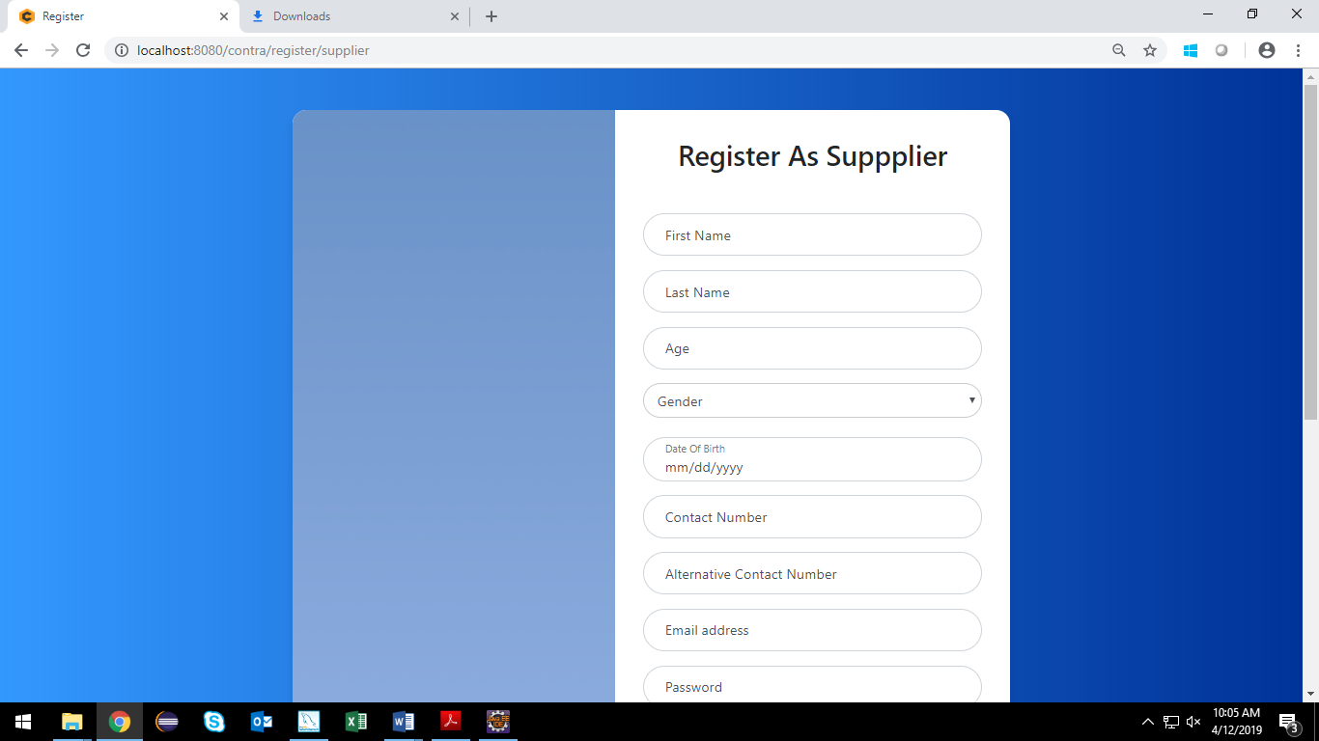

Admin Registration

Functional Requirement
Admin register page checks the authentication of the user and based on his role, directs the user to the admin home page.

UI Validations
- All fields are mandatory.
- Password should have maximum 15 alphanumeric, space & can contain special characters (ex.!,@,#,%,*,& etc.)
- The Email ID format must be checked.
- Contact Number must be of 10 digits’ length.
- Age should be 2 digit numeric value.
- First Name, Last Name should contain only alphabets.
- Gender should be chosen from the dropdown options.

UI Controls
# | UI Component | Type | Name | Details
1 | First Name | Text Field | first_name | To enter first name
2 | Last Name | Text Field | last_name | To enter last name
3 | DOB | Text Field | dob | To enter date
4 | Age | Text Field | age | To enter age
5 | Gender | Text Field | gender | To enter gender
6 | Contact Number | Text Field | number | To enter contact no
7 | Alternate Contact No. | Text Field | alt_number | To enter alternate contact number
8 | Email Id | Text Field | emailId | To enter email id
9 | Password | Password Field | password | To enter password

UI Methods Definition
Method Name | Parameter | Details
Sign_Button | object user, | Allows the user return to the login page
Register_button | Object user | Allows the user to submit the entered details.

UI Design
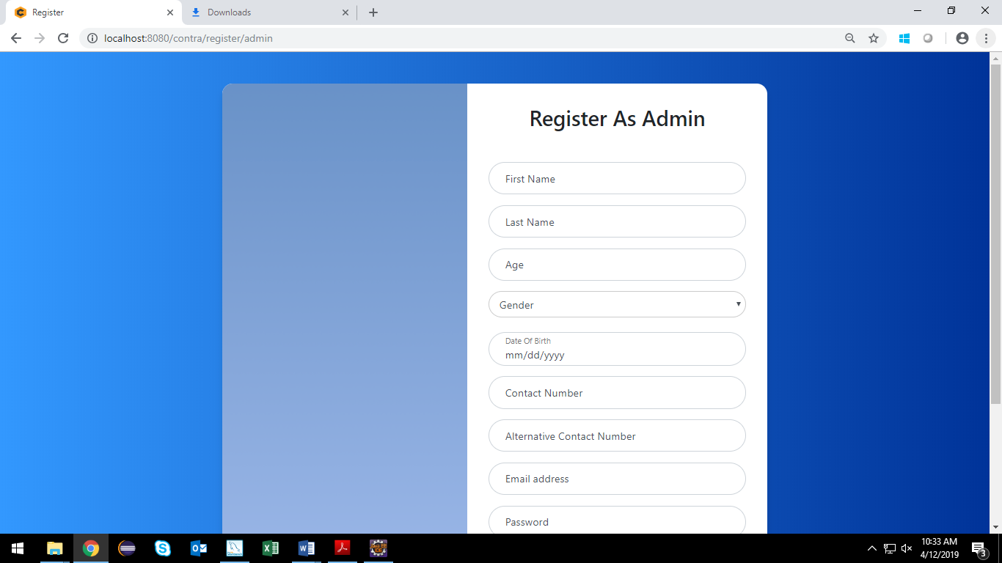

Contract Addition

Functional Requirement
. Supplier should be able to enter the contract description, amenities and terms and conditions.

UI Validations
- All fields are mandatory.
- Contract’s description should not exceed 100 characters.

UI Controls
# | UI Component | Type | Name | Details
1 | Contract Description | Text Field | decription | To enter contract’s description.
2 | Term 1 | Text Field | term1 | To enter term 1
3 | Term 2 | Text Field | term2 | To enter term 2
4 | Term 3 | Text Field | term3 | To enter term 3
5 | Term 4 | Text Field | term4 | To enter term 4
6 | Term 5 | Text Field | term5 | To enter term 5
7 | Amenity 1 | Text Field | amenities1 | To enter amenity 1
8 | Amenity 2 | Text Field | Amenities2 | To enter amenity 2
9 | Amenity 3 | Text Field | Amenities3 | To enter amenity 3
10 | Amenity 4 | Text Field | Amenities4 | To enter amenity 4
11 | Amenity 5 | Text Field | Amenities5 | To enter amenity 5
12 | Other info | Text Field | Other_info | To enter other information.

UI Methods Definition
Method Name | Parameter | Details
Sign_Button | Object user, | Allows the user return to the login page
next_button | Object user | Allows the user to submit the entered details.
previous_button | Object user

UI Design
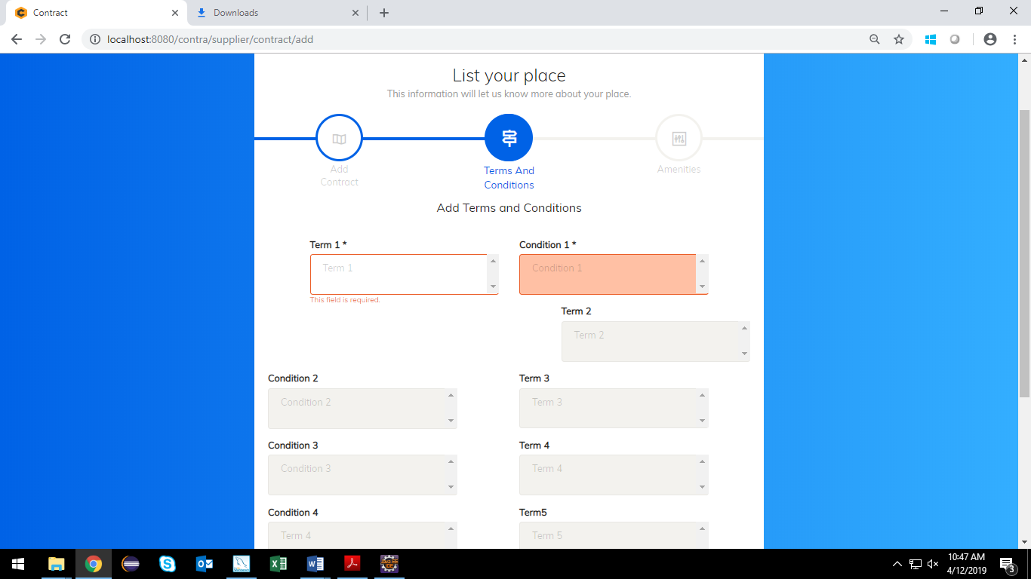

Database Design

Data Model

The following is a schematic view of the database design
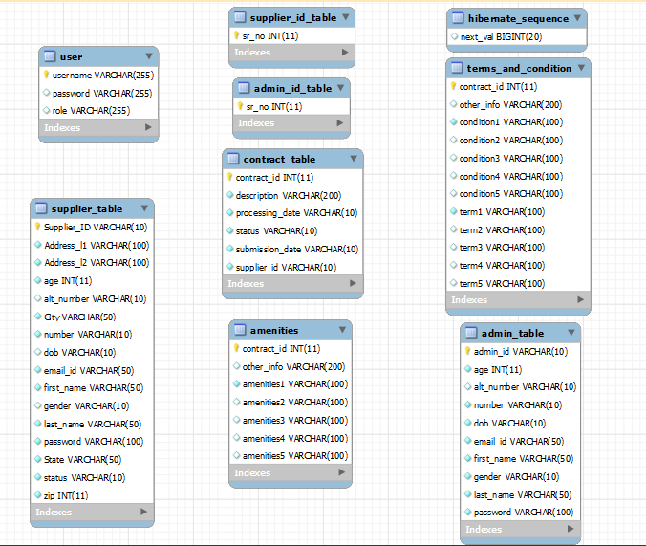

Tables Structure
Supplier:
Field Name | Field Type | Datatype | Mandatory | Possible values
Supplier ID | Text(10) | Alphabetic | Yes | System Generated
Password | Text(50) | Alphanumeric | Yes
First Name | Text(50) | Alphabetic | Yes
Last Name | Text(50) | Alphabetic | Yes
Age | Numeric(2) | Numeric | Yes
Gender | Drop Down | NA | Yes | Male, Female
Contact Number | Text(10) | Numeric | Yes
Alternate Contact Number | Text (10) | Numeric | No
Email | Text(50) | Alphanumeric | Yes
Address 1 | Text(100) | Alphabetic | Yes
Address 2 | Text(100) | Alphabetic | Yes
Zipcode | nvarchar | Numeric | Yes
City | Text(50) | Alphabetic | Yes
State | Text(50) | Alphabetic | Yes
Date of birth | Text(10) | Alphanumeric | No

Admin:
Field Name | Field Type | Data Type | Mandatory | Possible Values
Admin Id | Text(10) | Alphabetic | Yes | System Generated
First Name | Text(50) | Alphabetic | Yes
Last Name | Text(50) | Alphabetic | Yes
Age | Numeric(2) | Numeric | Yes
Gender | Drop Down | NA | Yes | Male, Female
Contact Number | Text(10) | Numeric | Yes
Alternate Contact Number | Text(10) | Numeric | Yes
DOB | Text(10) | Alphanumeric | No
Email Id | Text(50) | Alphanumeric | Yes

Contract:
Field Name | Field Type | Data Type | Mandatory | Possible Values
Field Name | Field Type | Data Type | Mandatory | Possible Values
Contract ID | Auto-generated(8) | Numeric | Yes | Non-editable system generated
Contract Description | Text(200) | Alphabetic | Yes
Contract Submission Date | Text(10) | Alphanumeric | Yes
Contract Processing Date | Text(10) | Alphanumeric | Yes
Contract status | Text (10) | Alphabetic | Yes | Submitted Approved Denied

Terms and Conditions:
Field Name | Field Type | Data Type | Mandatory | Possible Values
Field Name | Field Type | Data Type | Mandatory | Possible Values
Contract ID | Auto-generated(8) | Numeric | Yes
Term1 | Text(100) | Alphabetic | Yes
Term2 | Text(100) | Alphabetic | No
Term3 | Text(100) | Alphabetic | No
Term4 | Text(100) | Alphabetic | No
Term5 | Text(100) | Alphabetic | No
Condition1 | Text(100) | Alphabetic | Yes
Condition2 | Text(100) | Alphabetic | No
Condition3 | Text(100) | Alphabetic | No
Condition4 | Text(100) | Alphabetic | No
Condition5 | Text(100) | Alphabetic | No
Other Info | Text(200) | Alphabetic | No

Amenities:

Field Name | Field Type | Data Type | Mandatory | Possible Values
Field Name | Field Type | Data Type | Mandatory | Possible Values
Contract ID | Auto-generated(8) | Numeric | Yes
Amenities1 | Text(100) | Alphabetic | Yes
Amenities2 | Text(100) | Alphabetic | No
Amenities3 | Text(100) | Alphabetic | No
Amenities4 | Text(100) | Alphabetic | No
Amenities5 | Text(100) | Alphabetic | No
Other Info | Text(200) | Alphabetic | No

Change Log
Please note that this table needs to be maintained even if a Configuration Management tool is used.
Version Number | Changes made
V1.0 | <First version>
V1.1 | <If the change details are not explicitly documented in the table below, reference should be provided here>
V1.1 | Page no | Changed by | Effective date | Changes effected
V1.2 | <If the change details are not explicitly documented in the table below, reference should be provided here>
V1.2 | Page no | Changed by | Effective date | Changes effected

